TEAM ID:PNT20225MID07730

KEERTHIVARMAN B

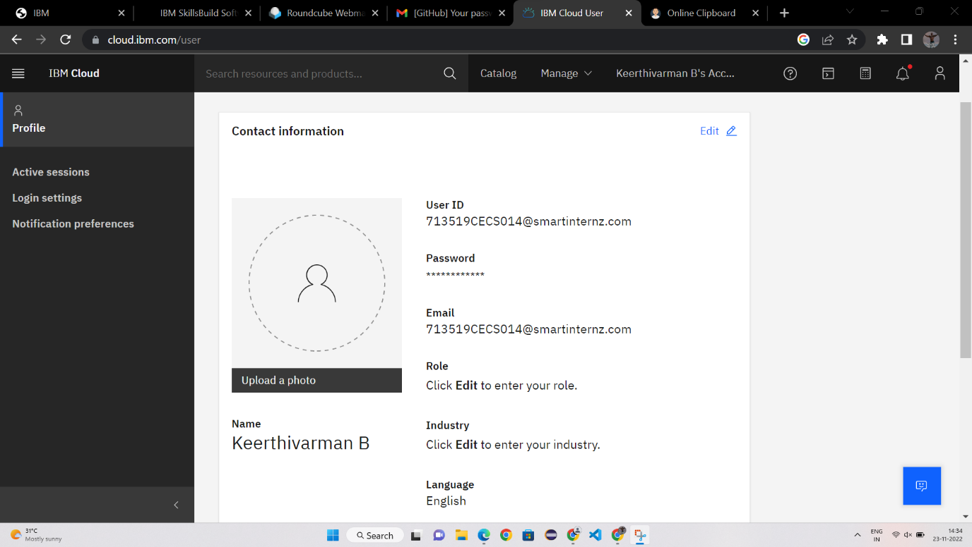

VINOTHKUMAR N

1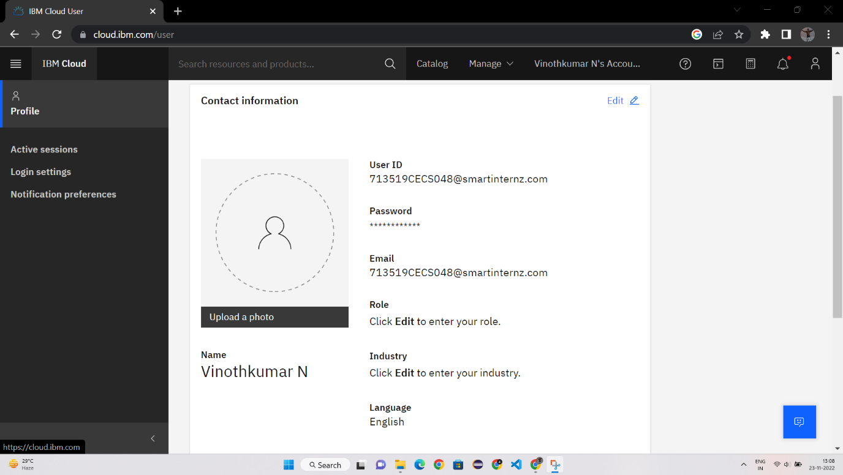

DHARUN M S

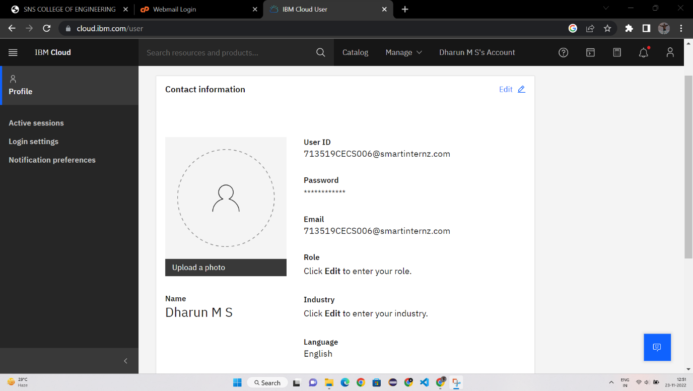

DHEIVA PRAKASH R

